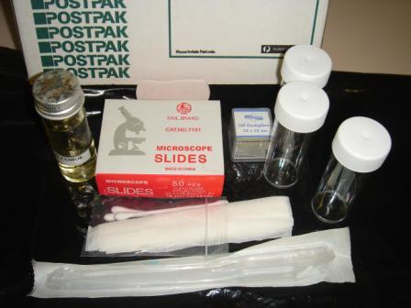
Microscope kit
Contains:
1 box of microscope slides
1 box of cover slips
1 bottle alcohol
3 plastic collecting tubes
1 sterile Pasteur pipette
Lens tissue
Cotton buds

Kit alone $20.00

Packaging & Registered post inside Australia $25.00

Postage address:
Name: |  | Organisation:
Address: |  | Phone:
Mobile: |  | Email:
Total Payable | $

PAYMENT METHOD: Select your payment option:

Master card |  |  |  | VISA |  |  |  |  | Cheque Enclosed |  |  |  | Direct Payment
Credit card: | Card# |  |  |  |  |  |  |  |  | Expires: |  |  |  | CVV
 |  |  | 4 digits |  | 4 digits |  | 4 digits | 4 digits |  |  | 2 digits | 2 digits |  |  | 3 digits
 |  | Name on card:
Do you need to be invoiced to activate payment? YES NO
Cheque made payable to Agpath P/L., 105 Gunn Road, Vervale, 3814 Vic
Direct payment: BSB: 633-000 Account: 132 079 997 (specify name or that of your organisation)

Further information contact:

Dr Mary Cole, agpath@dcsi.net.au or 0413 013 247

Please look at Agpath website www.agpath.com.au for information pertaining to courses; diary events; interesting papers/ articles; fire alerts for wine industry.
This form will be a tax invoice for GST when completed and payment is made.

